Tic Tac Toe User Manual

This program is a Tic Tac Toe Game that you can play with two people or against the computer. When you launch the game, you are given a menu screen.

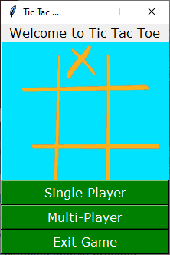

* Single Player – Select this to play against the computer.
* Multi-Player – Select this to play with another person
* Exit Game – This takes you to a splash screen and then closes the program

Single Player

* Select your square.
* The computer will automatically select its square
* Continue to select squares until the board is full or one player wins the game

Multi-Player

* Player 1 is X, Player 2 is O
* The player that is not grayed out is to select a square
* Then the next player will not be grayed out and will get to select a square
* Once the board is full or you have a winner, the board will ask if you want to play again

If you select no to playing again this splash screen shows up to thank you for playing.

Otherwise, it goes back to the menu for you to select your new game type.